

SRI LANKA INSTITUTE OF INFORMATION TECHNOLOGY

[**Enterprise Standards and Best Practices for IT Infrastructure**](http://courseweb.sliit.lk/course/view.php?id=137)

**4th Year 1st Semester 2016 (June Intake)**

Name: N.A.I. Dhanushka

SLIIT ID: IT13136666

Practical Session: <WD / WE Monday/ WE Thursday>

Practical Number : <Lab 1>

Date of Submission: 30/07/2016

Date of Evaluation : _____________________

Evaluators Signature : _____________________

Windows

First you have to create or sing in AWS Account

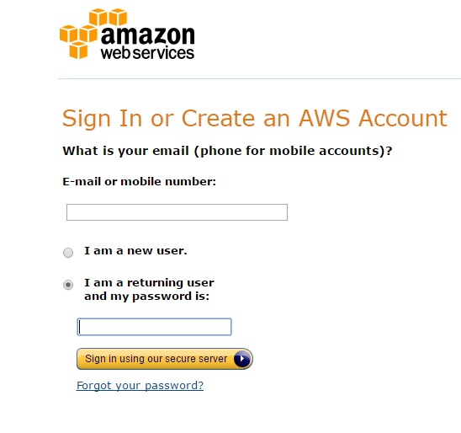

Then you are enter to Amazon Web services page, click EC2 (virtual servers in the cloud)

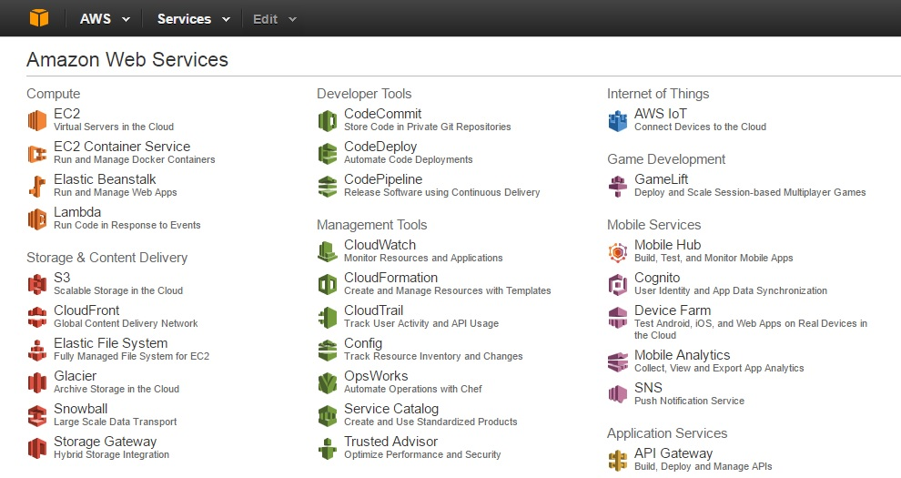

EC2 Dashboard is seen below, Click “**Launch Instance**” to create new Windows Instance

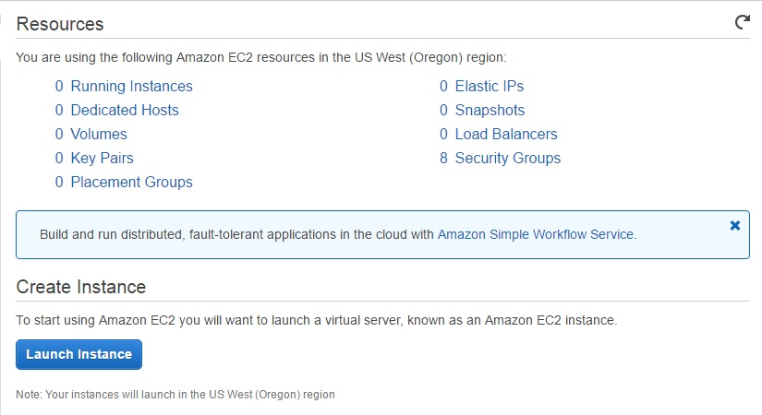

Click Select in “Microsoft Windows Server 2012 R2 Base”

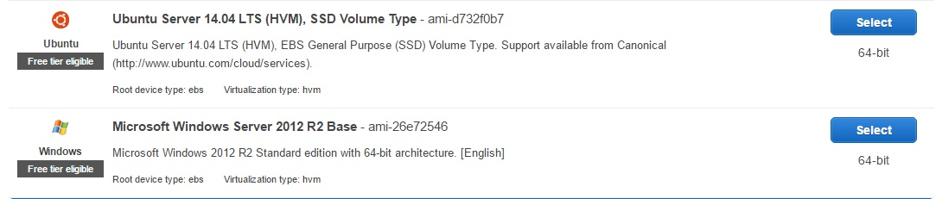

Choose an Instance type, click “Review and Launch”

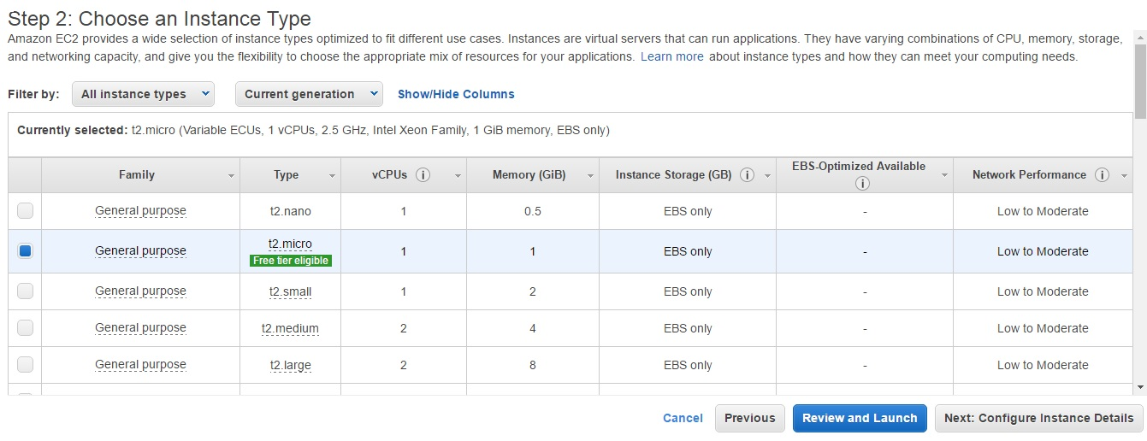

Review Instance Launch Click “Launch”

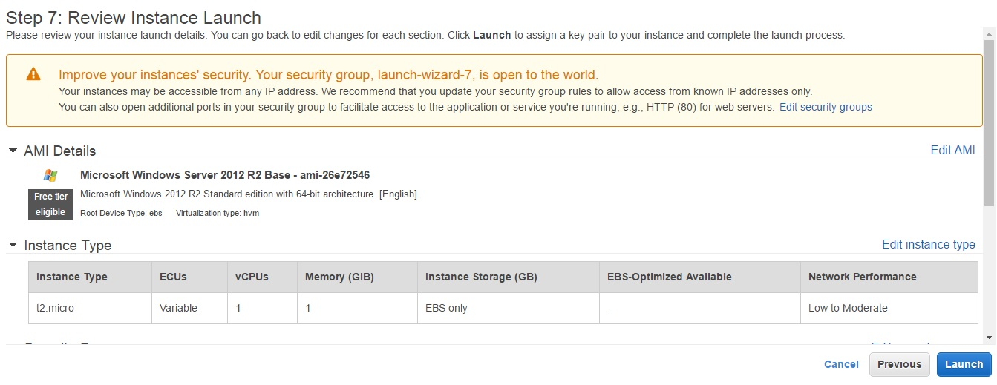

First drop down list we select “Create a new key pair” and give to Key pair name then click “Download key pair”

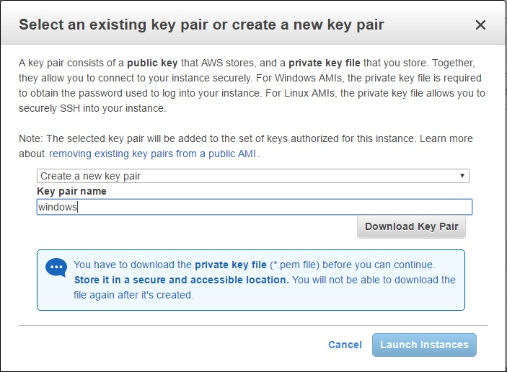

You can see this Launch Status, go to page down

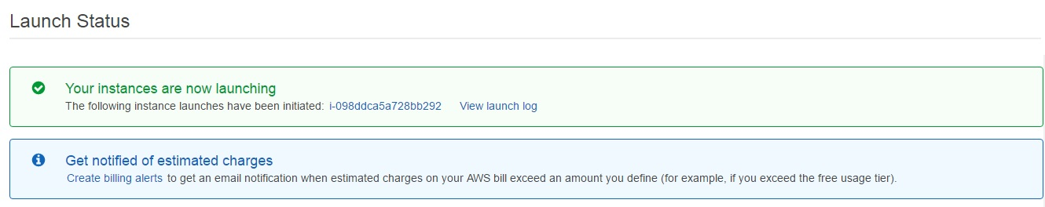

Click “View Instance”

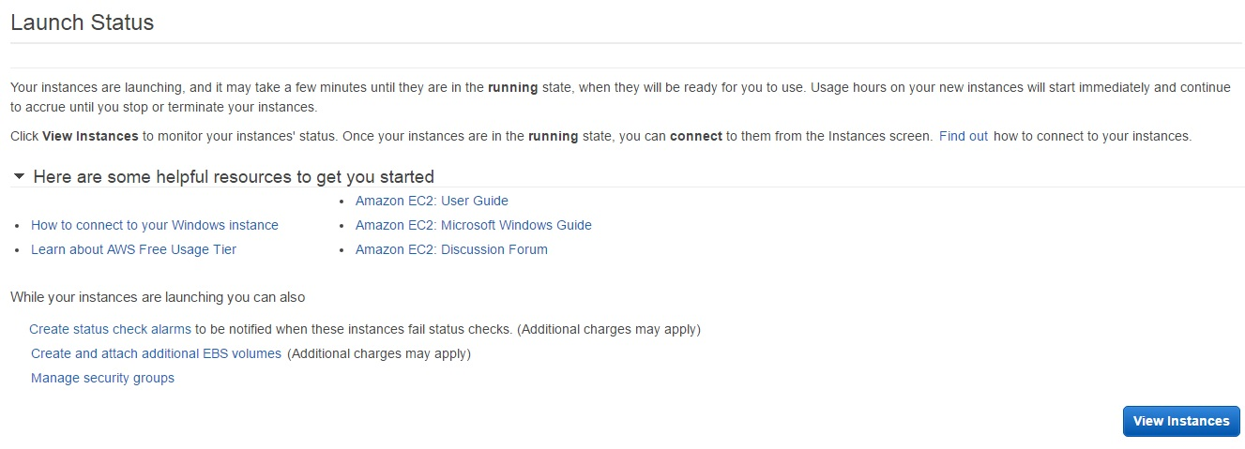

Then tick “Windows Instance” And Click “Connect”

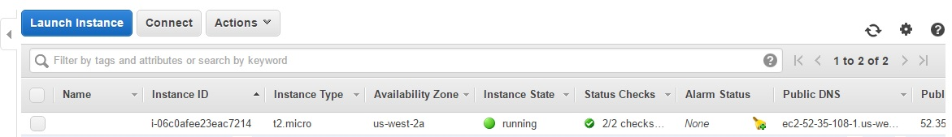

Then you can see Connect to Your Instance window and Click “Get Password”

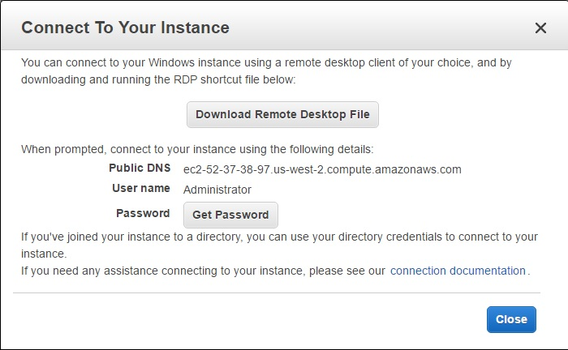

After click Get Password Button show this windows, than get the key pair path Click the “Choose File” after select the key click “Decrypt Password” and click “Close”

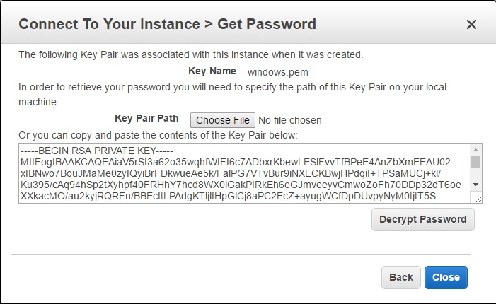

Then you can see Decrypted Password

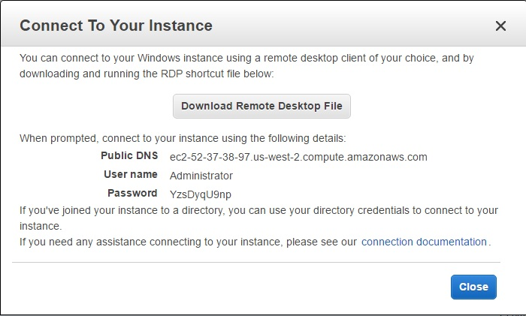

Run “Remote Desktop Connection” and click “Connect”

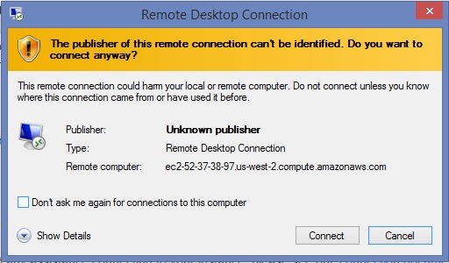

Then display this window you have to give Decrypted Password to password textbox

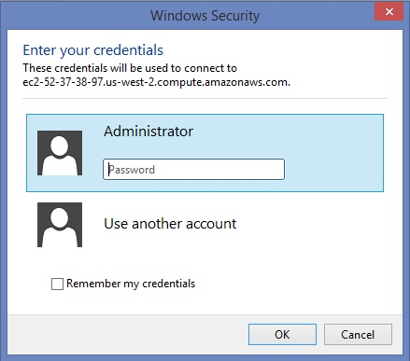

Click “Yes”

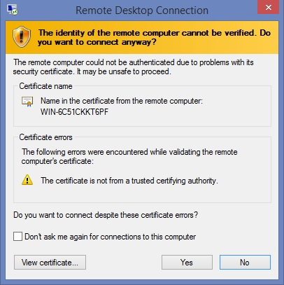

Now you can see “Windows Server”

